

**ASSIGNMENT -3**

**COURSE: DevOps Name: K. MONIKA**

**MODULE: Terraform s3 Gmail: monikakudithetti@gmail.com**

**TRAINER: Mr. Madhukar sir Batch no: 120 - 5pm**

**Date: 21-03-2024**

**Creation of s3 bucket and upload of the files to the s3 bucket.**

**Step 1:** I have created an EC2 instance with ‘terraform-s3’ name and also selected the ami as ‘Ubuntu’ and then launch the instance.

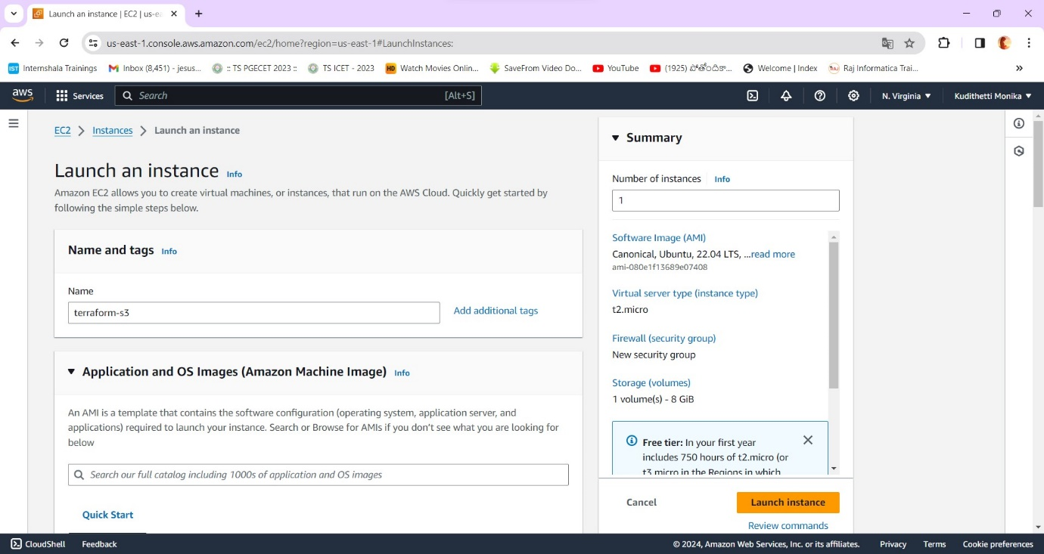

**Step 2:** Connect the ec2 instance. And then I used the update command.

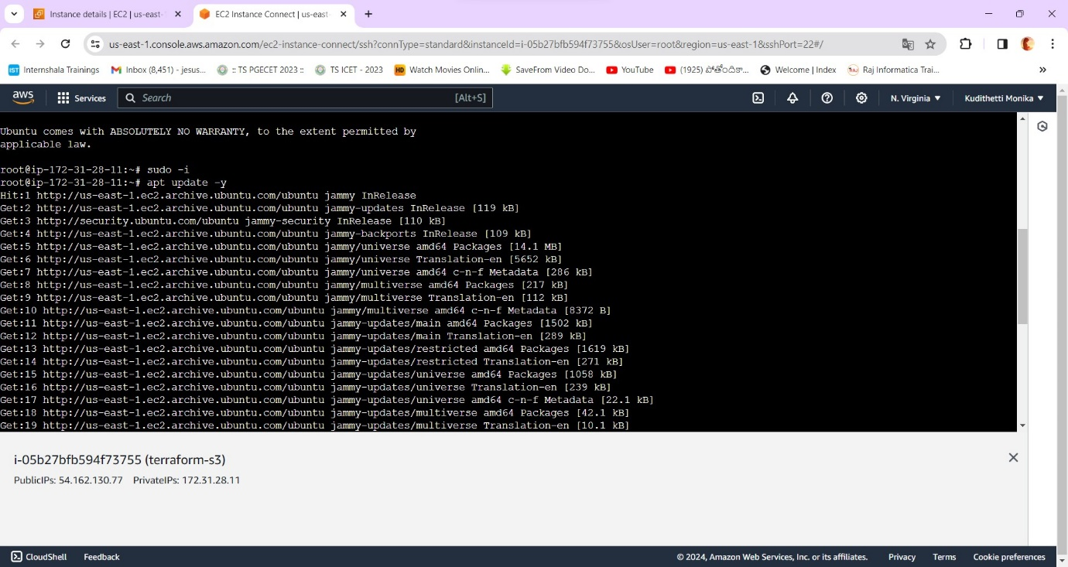

**Step 3:** Then I installed awscli as follows.

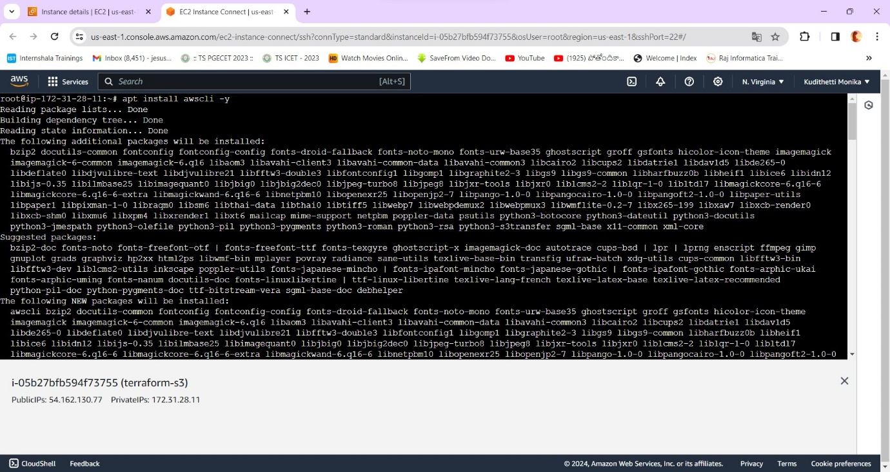

**Step 4:** Go to IAM and then to Users and create a user name with administrative access.

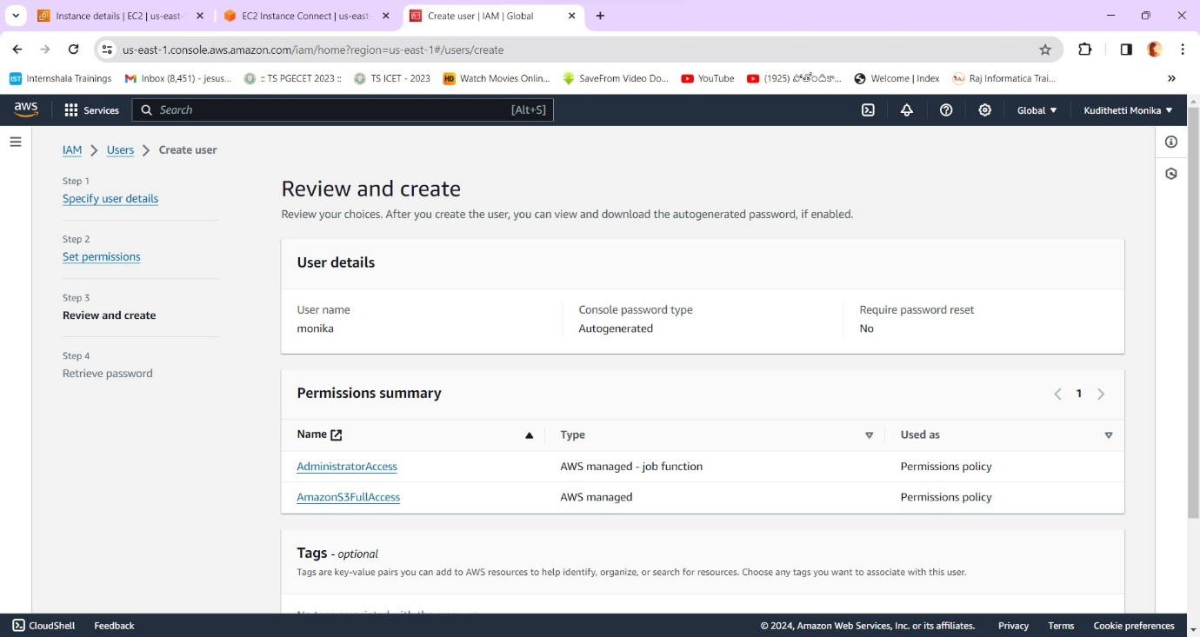

**Step 5:** Now click on create access key .

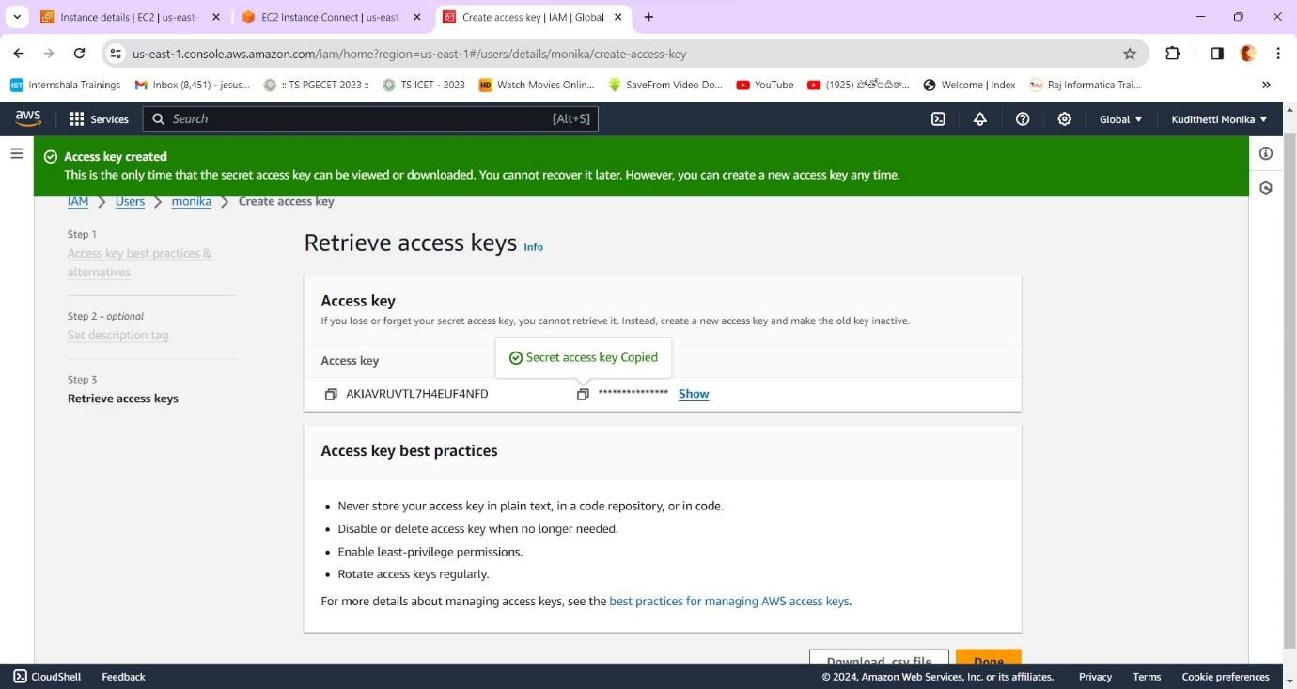

**Step 6:** Now go to the server and type the command ‘aws configure’ to copy paste the secret access key password and ID ,to make connection between terraform and the AWS console.

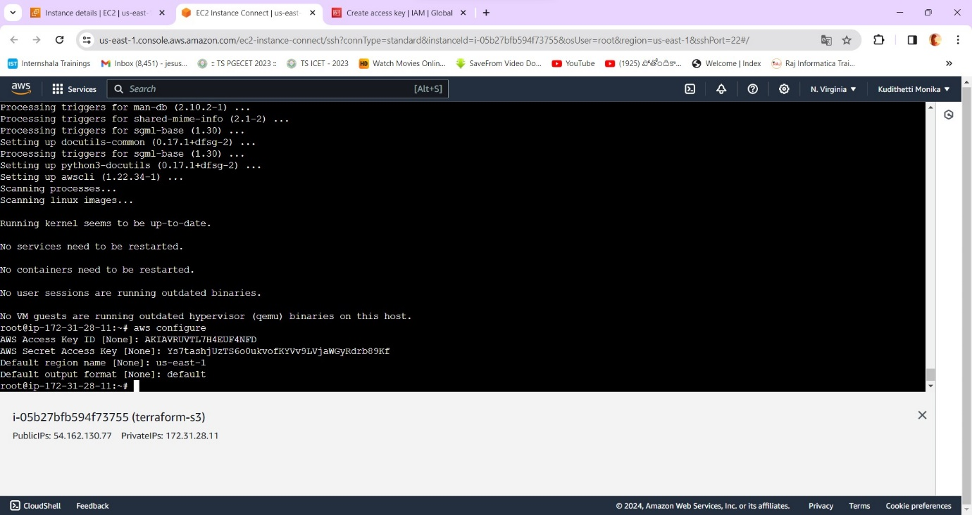

**Step 7**: I have changed the default name as moni321 in credentials ,config files of .aws as below.

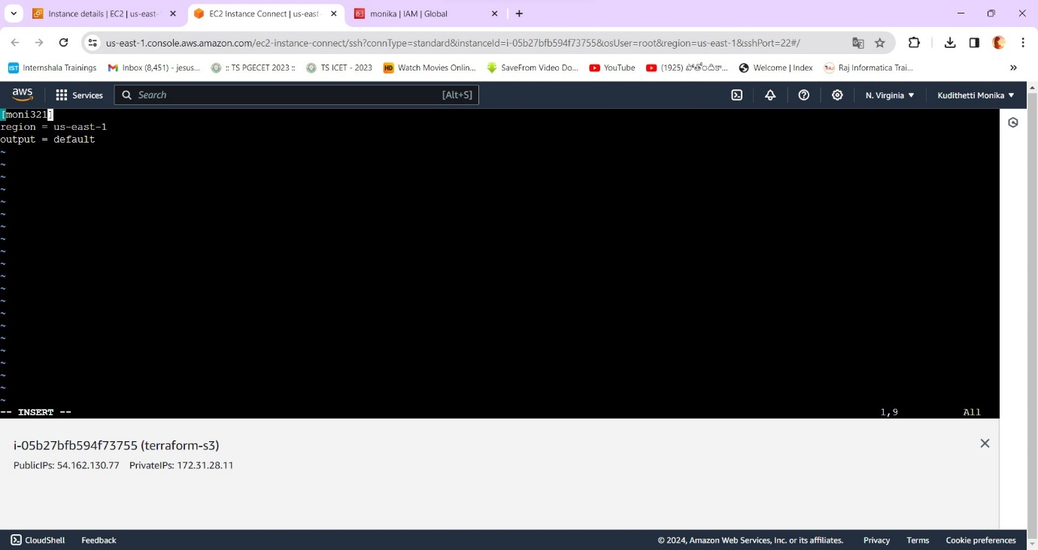

**Step 8:** Also create a terraformblock.tf as follows.

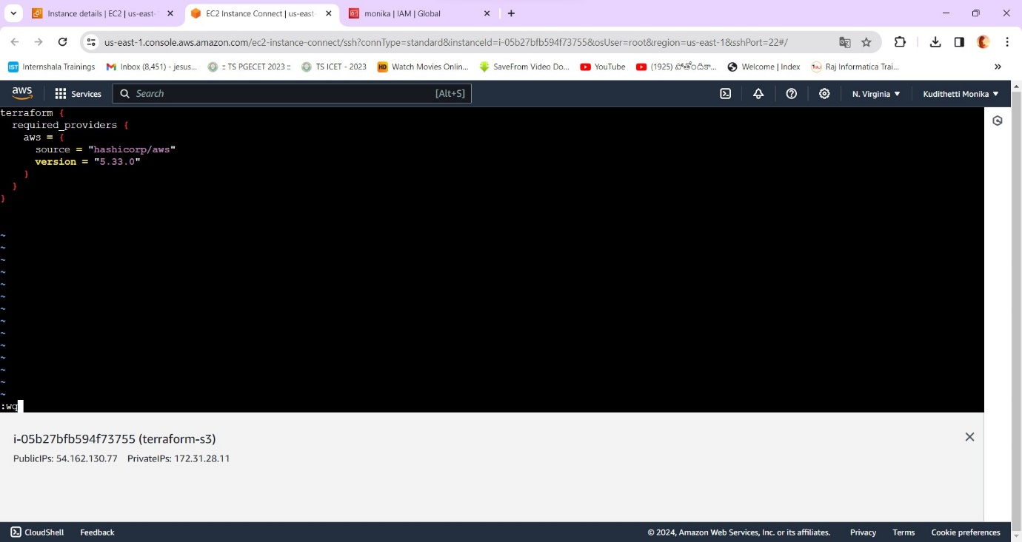

**Step 10**: Install terraform using the following command.

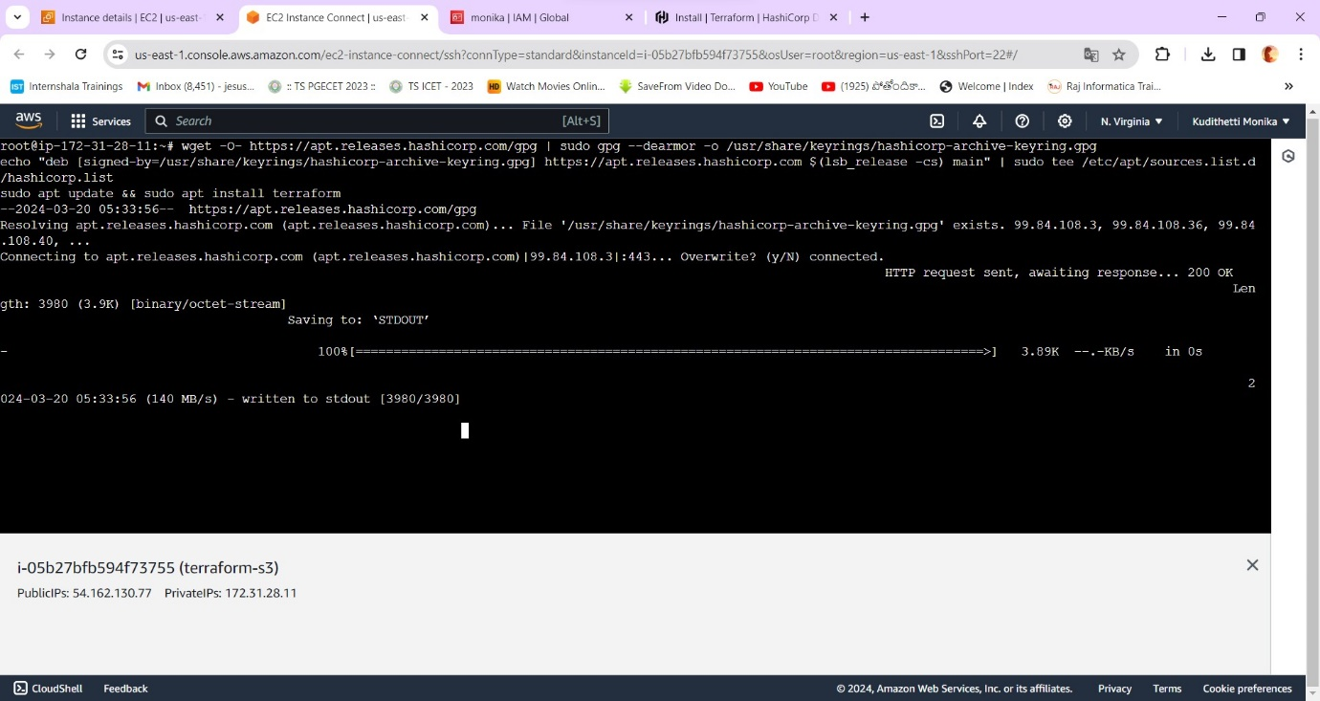

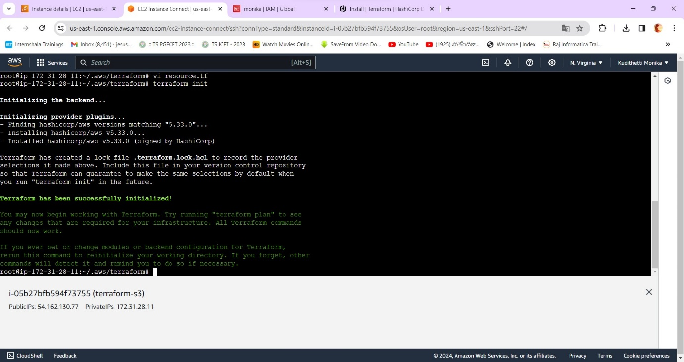

**Step 12:** Also create provider.tf block as follows.

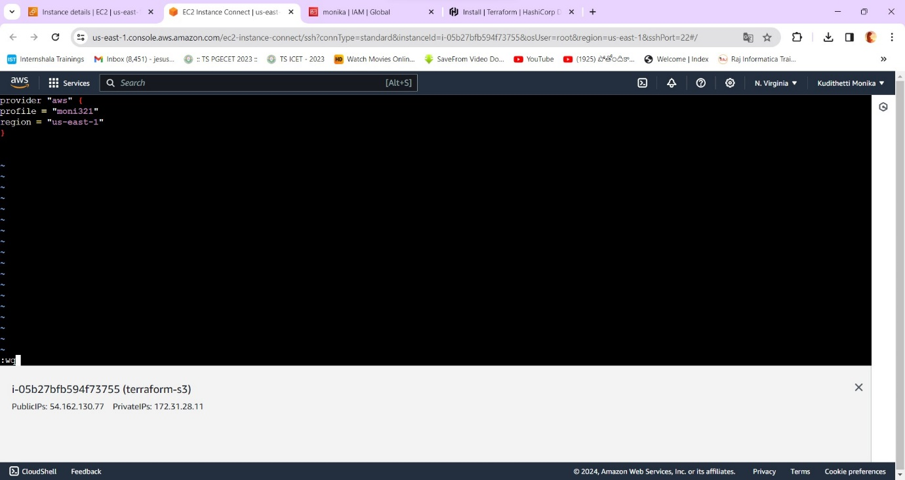

**Step 13:** Finally create the resource.tf file and the bucket creation code in it . Also insert the name and the path of the file in it as below.

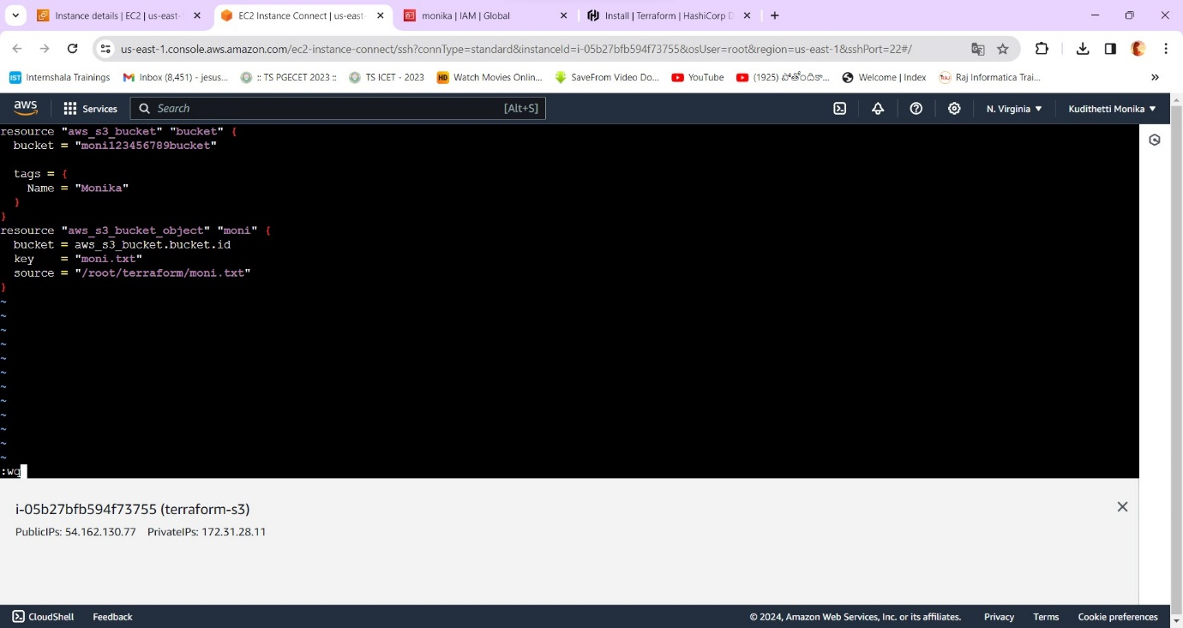

**Step 14**: The bucket has been created in the given region successfully!

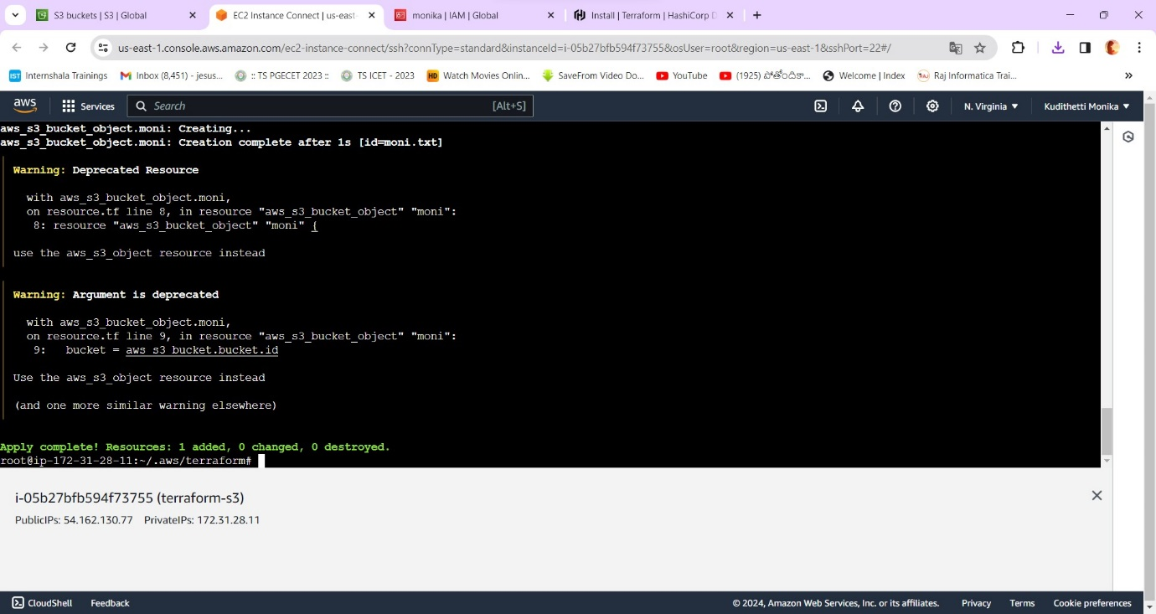

**Step 16**: Go and check the bucket in the aws console.

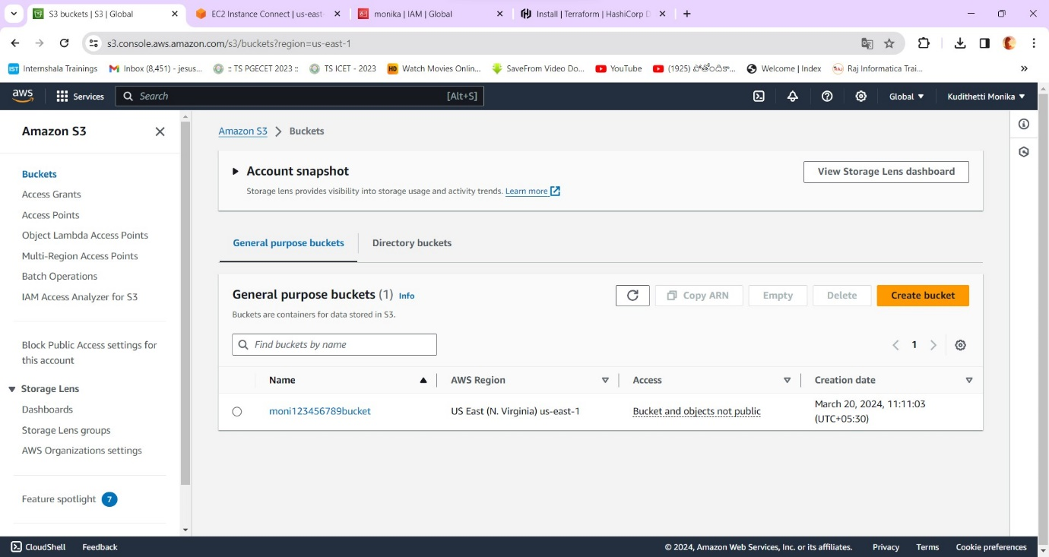

**Step 17:** The file is also present in the bucket.

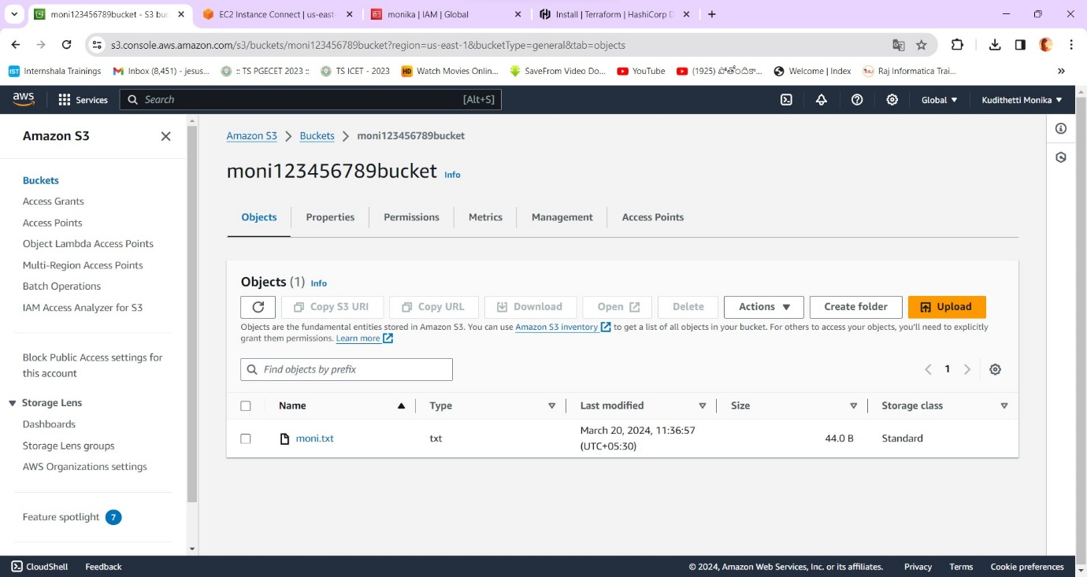

**Step 18:** At last destroy the bucket using ‘terraform destroy’ command.

